Contents
1. Kubernetes vs Docker 1
2. kubectl cluster-info Results 1
3. Deployment → ReplicaSet → Pod Relationship 1
4. Why Service When Pods Have IPs? 1
5. Load Balancing Confirmation 2
6. v10 Failed Update & Rollback 2
SCREENSHOTS: 3

1. Kubernetes vs Docker
Docker runs individual containers but lacks orchestration. Kubernetes solves deployment, scaling, self-healing, load balancing, and rolling updates across clusters. Docker = single container runtime; Kubernetes = distributed systems manager.

2. kubect cluster-info Results
Revealed control plane endpoint (Minikube IP: 192.168.49.2:8443). The control plane (API server, scheduler, controller manager) receives kubectl commands, manages cluster state, schedules pods, and monitors health.

3. Deployment/Replica Set/Pod Relationship
Deployment declares desired state (# replicas, image). Creates Replica Set to maintain exact replica count. Replica Set creates/terminates Pods (running containers). Deployment - Replica Set - Pods (3-tier hierarchy).

4. Why Service When Pods Have IPs?
Pods are ephemeral - IPs change on restart/replacement. Service provides stable endpoint + load balancing across matching pods (via labels). Created Node Port service exposing port 8080 on high port 30374 on all nodes.

5. Load Balancing Confirmation
Load balancing was confirmed by scaling the Deployment to 4 replicas and observing multiple Pods running simultaneously, each with different IP addresses (e.g., 10.244.0.11, 10.244.0.12, 10.244.0.7, 10.244.0.13), all in a READY 1/1 Running state.
Repeated curl requests to the Service endpoint returned responses from different Pod instances (each showing a different Pod name in the output), demonstrating that traffic was being distributed across all replicas.
Additionally, the kubect get deployments output showing READY 4/4 confirmed that all replicas were active and available, proving that Kubernetes was successfully performing load balancing through the Service across multiple Pods.

4 pods with different IPs (10.244.0.11,12,7,13) already 1/1 Running confirmed Kubernetes service distributes traffic across replicas. kubectl get deployments READY 4/4 proved scaling + load balancing worked.

6. v10 Failed Update & Rollback
v10 pods entered ImagePullBackOff / ErrorImagePull state because the specified image version (v10) did not exist in the container registry. Kubernetes was unable to pull the image, so new Pods failed to start while older ones were being terminated during the rollout.
Kubernetes automatically paused progress as failures occurred, preventing a complete system breakdown. Using kubect rollout undo, the Deployment reverted to the previous stable version (v2). The Replica Set recreated healthy Pods with the valid image, returning all Pods to a Running state.
This demonstrates Kubernetes’ resilience and self-healing capabilities. It ensures application availability by detecting failed updates, stopping faulty rollouts, and allowing quick rollback to a known working state with minimal downtime.

SCREENSHOTS:

A)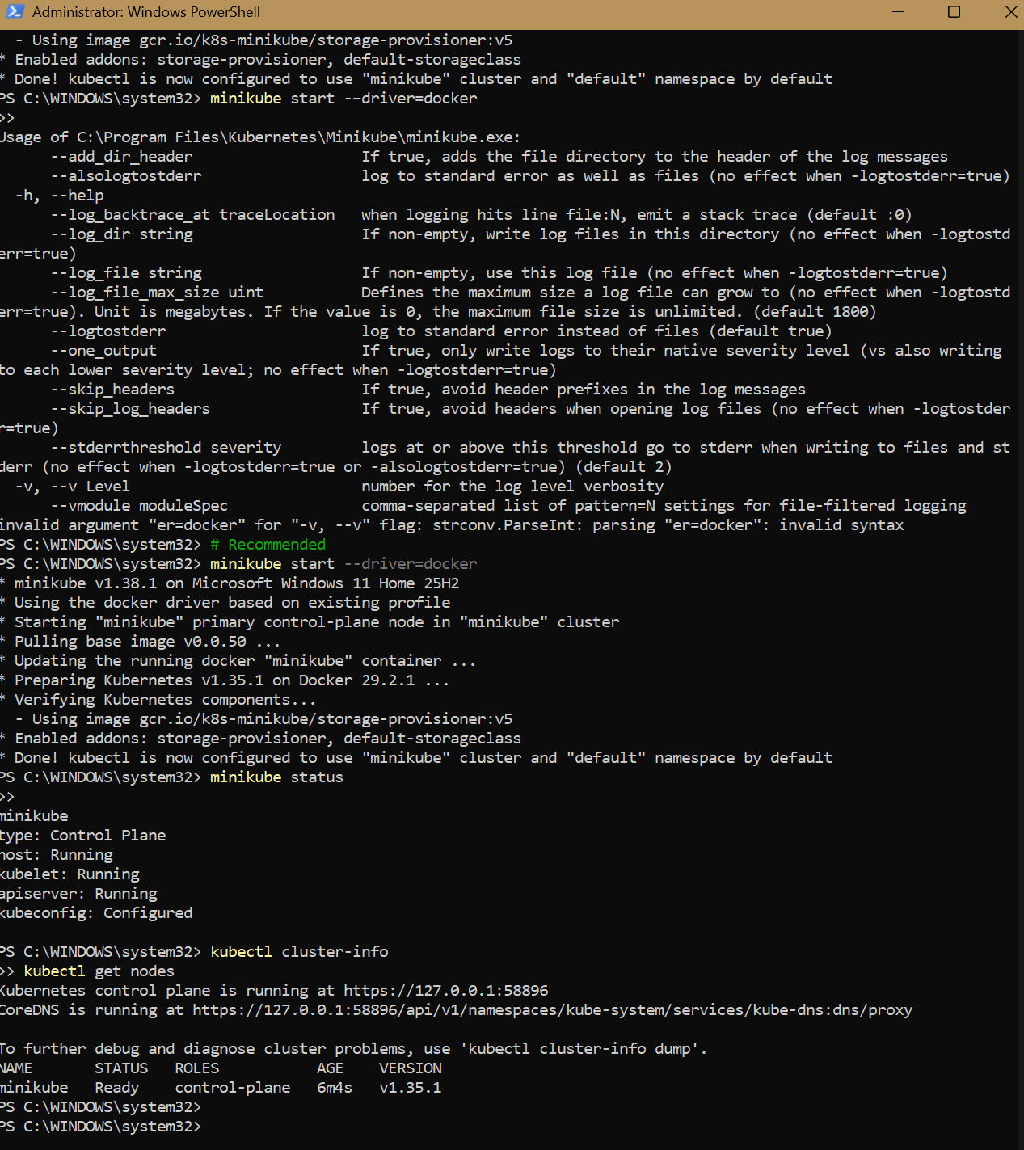
B)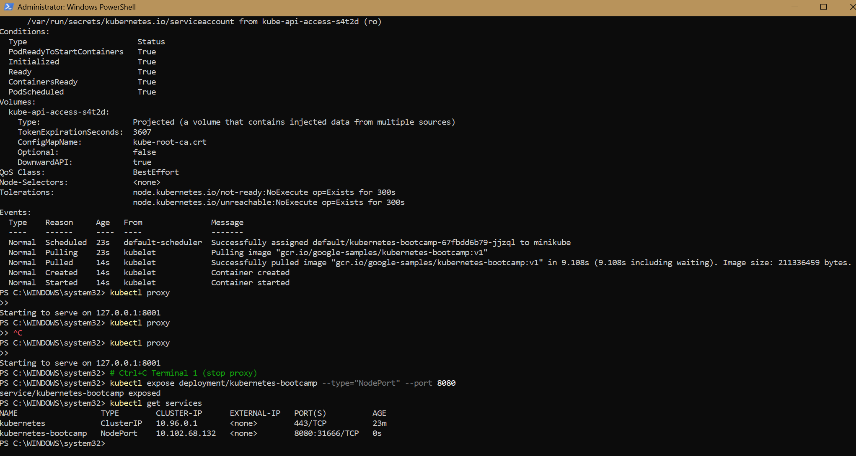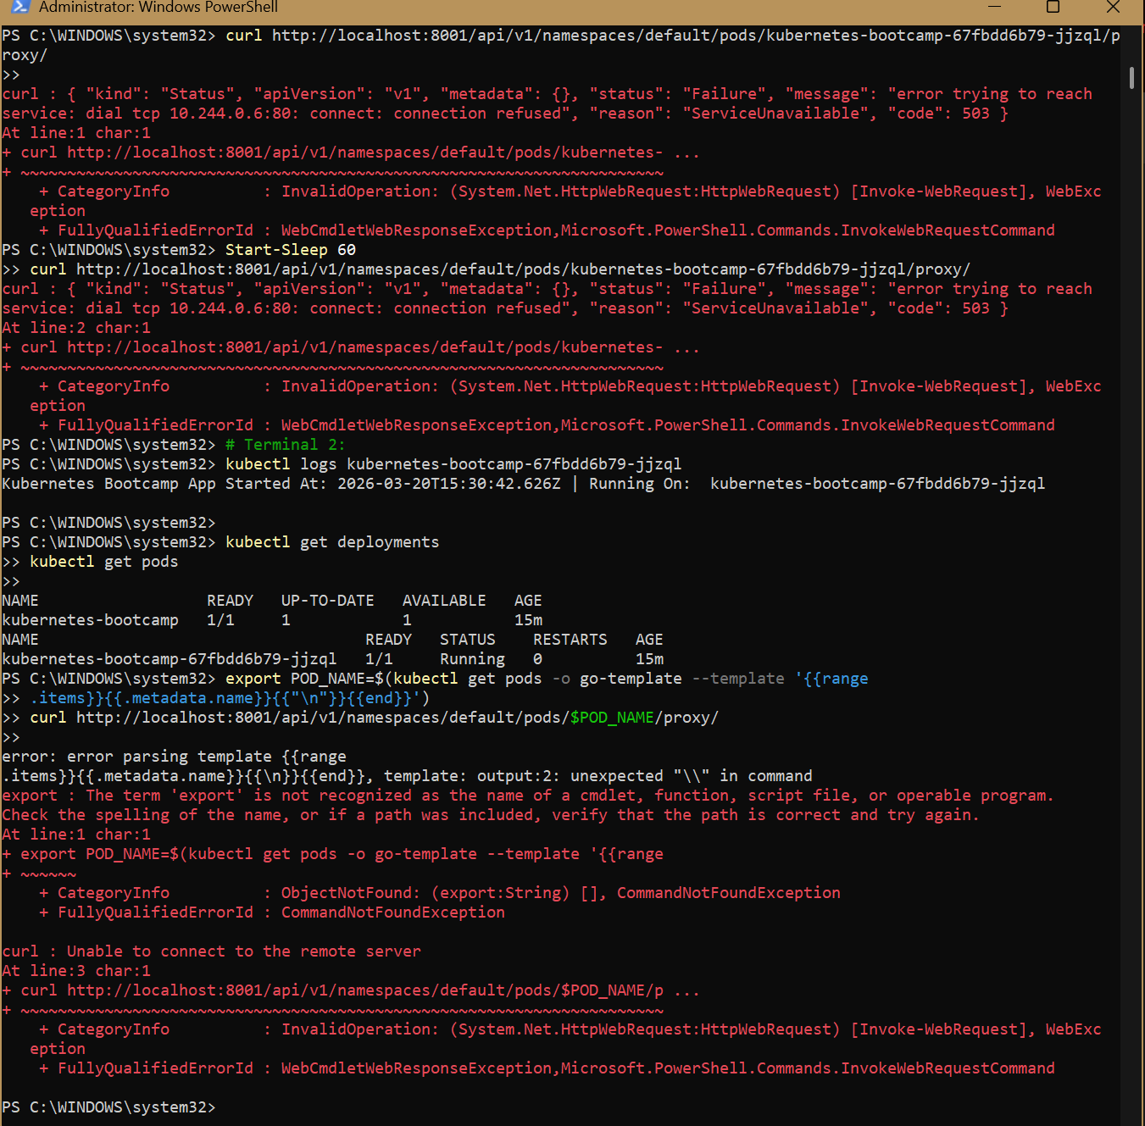
C)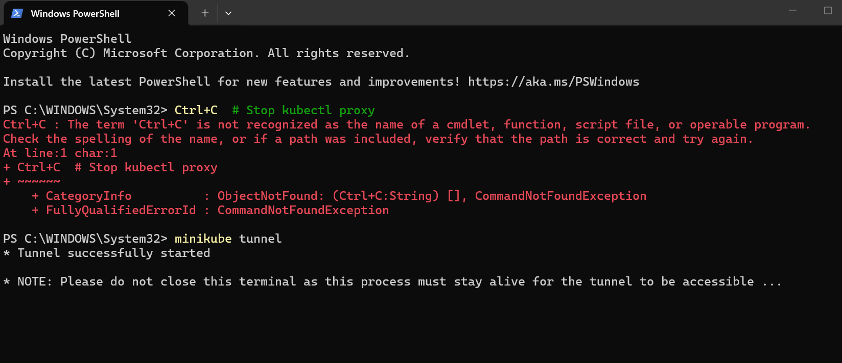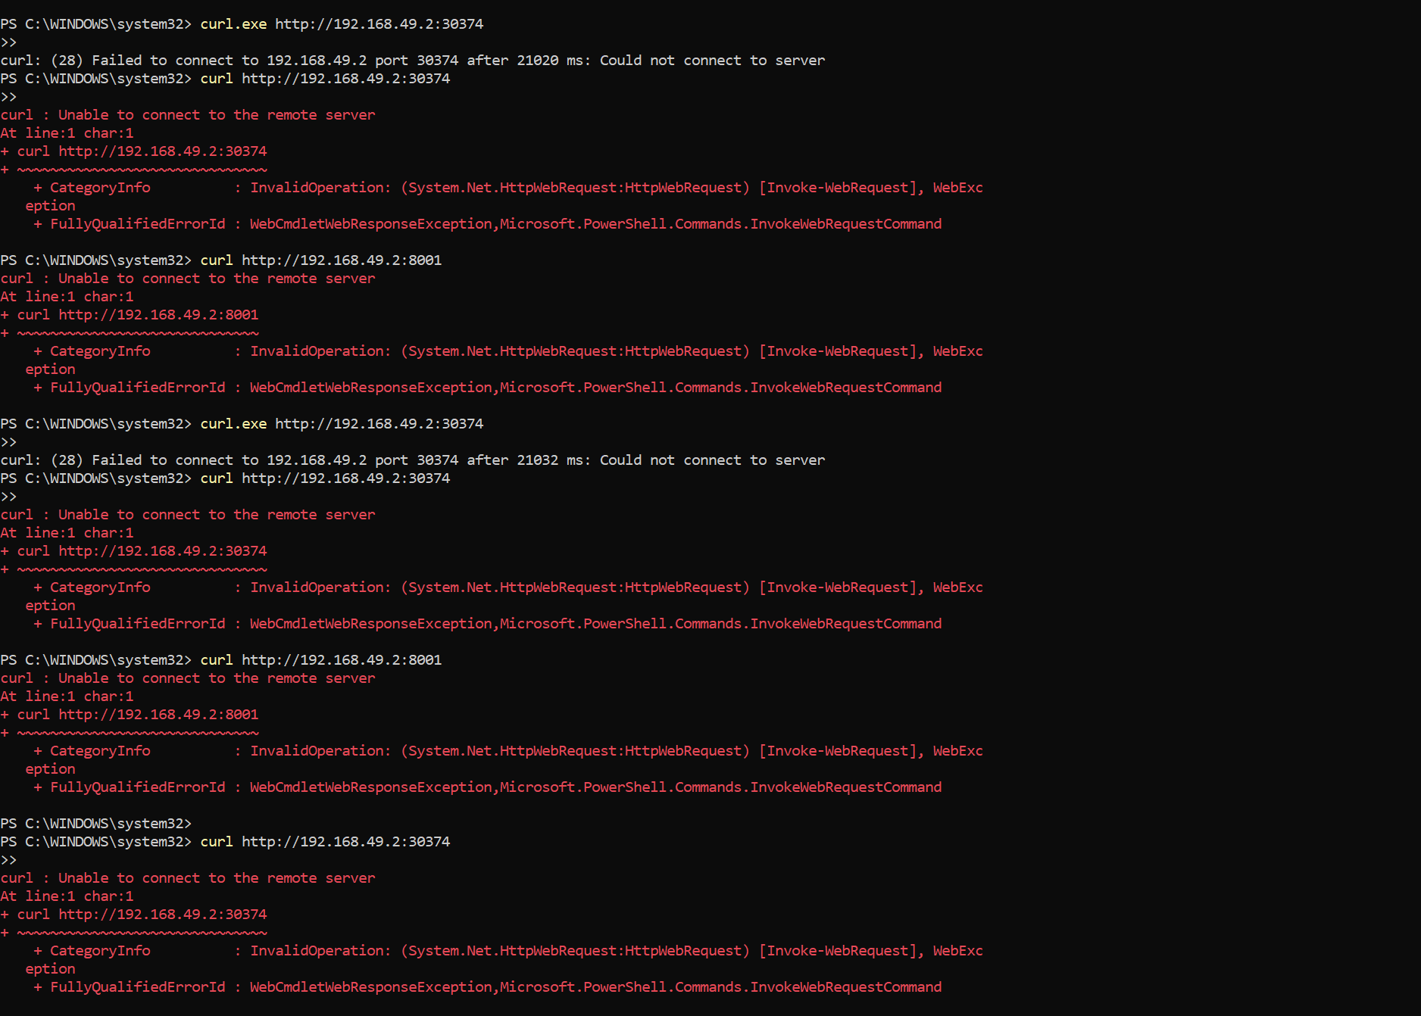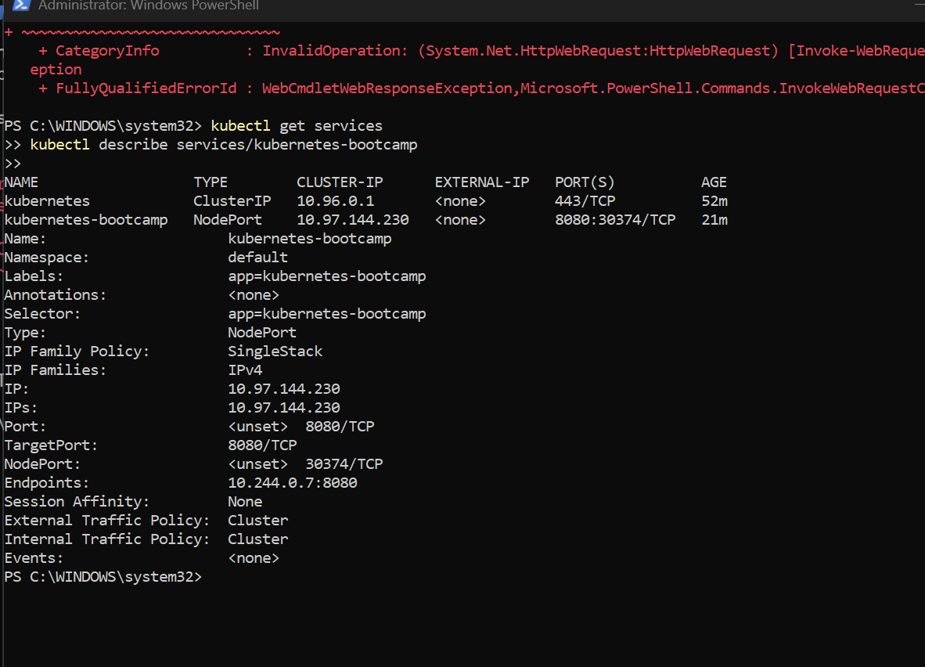
D)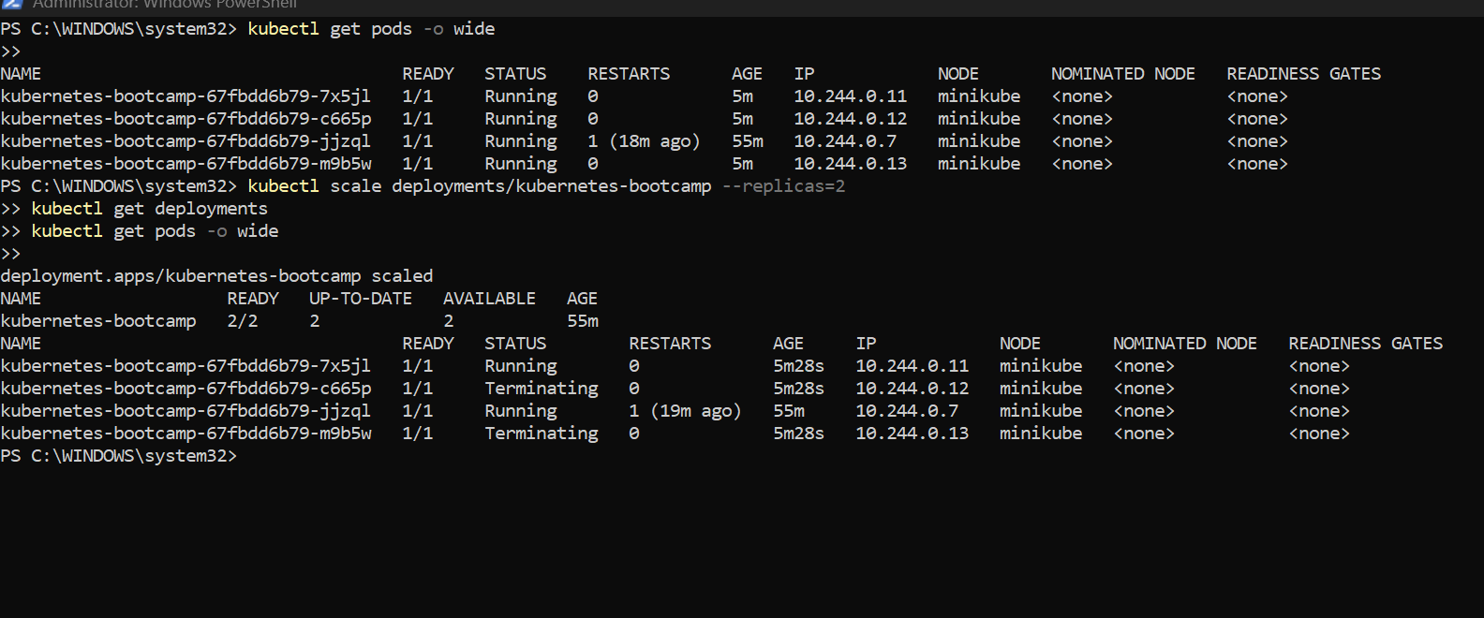

E)
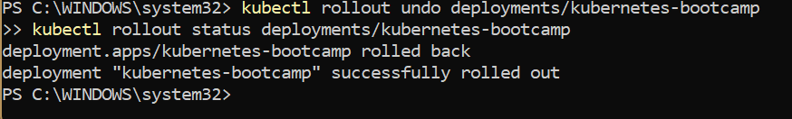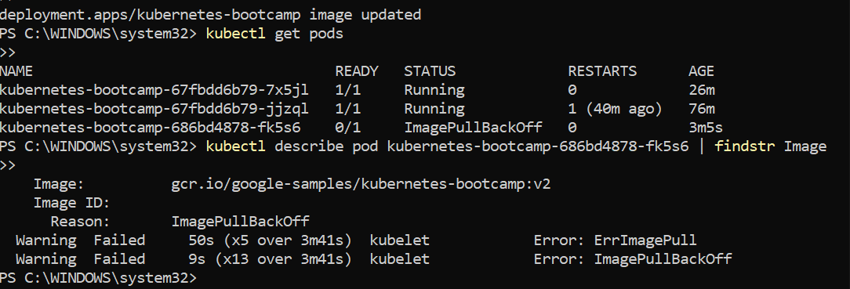

CLEANUP)